Jevin Redman
jevinredman13@gmail.com | (812) 746-6301 | www.jevinredman.com
EXPERIENCE:
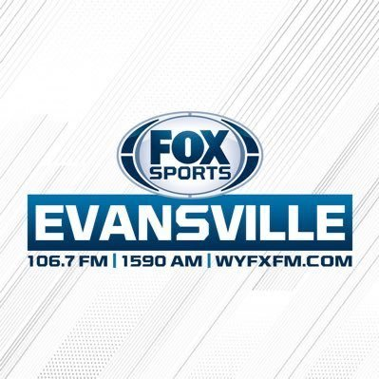
Fox Sports Radio Evansville Apr. 2019 - Present
- Sports Director
- Record/Produce Morning and Afternoon Sportscasts
- Production/Sales
- Coordinate Broadcast Schedule with Traffic
Learfield Sports (University of Evansville) Oct. 2018 - Present
- Radio Play-by-Play Broadcaster Evansville Men’s Basketball
- Radio Play-by-Play Broadcaster Evansville Baseball
- Host Weekly Radio Coaches Shows
- Emcee Summer Coaches Caravans and Events

ESPN 3 (University of Evansville) Sept. 2017 - Present
- TV Play-by-Play Broadcaster Basketball, Baseball, Softball, Volleyball
IHSAA Dec. 2012 – Present
- Licensed High School Basketball Official

IMG Sports Network (Western Kentucky University) Sept. 2017 – Oct. 2018
- Radio Play-by-Play Broadcaster Lady Toppers Basketball
- Radio Play-by-Play Broadcaster (Fill-In) Hilltopper Football
- Host Weekly Radio Coaches Shows
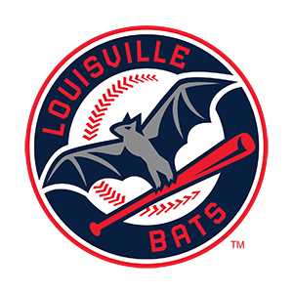
Louisville Bats (Triple-A Cincinnati Reds) Jan. 2017 – Sept. 2017
- Radio Play-by-Play Broadcaster
- Media Relations Assistant/Intern
- In-Game Social Media
Evansville Otters Mar. 2016 – Nov. 2016
- Director of Broadcasting and Radio Play-by-Play Announcer
- In Game Social Media
- Travel Coordinator
University of Southern Indiana Aug. 2013 – Mar. 2017
- Radio Play-by-Play for USI Women’s and Men’s Basketball
- Radio Play-by-Play for USI Baseball

AWARDS:
- Sportscasters Talent Agency of America Top 30 Under 30 Broadcaster (2018)
- Two-Time Jim Nantz Top 20 Collegiate Broadcaster Award (2016 & ‘17)
- College Broadcasters Inc. Best Sports Play-by-Play (2017)
- Best Play-by-Play Broadcaster in Indiana named by Indiana Broadcasters Association (2016)
- Broadcast Education Association Best Collegiate Play-by-Play Broadcaster in the nation (2015)

Education:
University of Southern Indiana
- Bachelor of Science, Marketing and Radio/Television Completed April 2017
- GPA: 3.6

References:
- Brandon Gaudin – Broadcaster - NFL Madden, Fox, Big Ten Network, Westwood One
- Brandon McClish – General Manager - Purple Aces Sports Network
- Nick Curran – Broadcaster - Louisville Bats (Triple-A Reds), Louisville WBB
- Chris Bloomfield – VP of Sales and Development – Learfield IMG College (Central Region)
- Tom Benson – Assistant AD/Producer - Purple Aces Production ESPN 3

